Data Visualization and Analysis using R

Yuva Intern – Week 2 Task
Dataset: Air Quality Missing Data
Name: Mahesh
Tools Used: R, RStudio, Microsoft Word

1. Dataset Overview
The dataset used for this project is an Air Quality dataset containing daily observations of air pollution and weather-related variables.

The dataset contains 153 observations and 5 important variables:

• Date – Date of the observation.
• Ozone – Ozone concentration recorded in the air.
• Solar – Solar radiation measurement.
• Wind – Wind speed.
• Temp – Temperature recorded for the observation.

The dataset was cleaned in Week 1 and is being used again in Week 2 to create meaningful visualizations and identify patterns and relationships in the data.

The main purpose of this visualization task is to understand the relationship between temperature and ozone, observe temperature trends over time, and study the distribution of ozone values.

2. Visualization 1: Ozone vs Temperature
Purpose:
A scatter plot was selected to examine the relationship between temperature and ozone concentration. Each point represents one observation from the dataset. This type of visualization makes it easier to identify whether ozone values tend to change as temperature changes.
R Code:
plot(
Air_Quality_Cleaned$Temp,
Air_Quality_Cleaned$Ozone,
main = "Ozone vs Temperature",
xlab = "Temperature",
ylab = "Ozone",
pch = 19,
cex = 1.2
)
Interpretation
The scatter plot shows a generally positive relationship between temperature and ozone concentration. As temperature increases, ozone values tend to increase in this dataset. The points are somewhat scattered, so the relationship is not perfectly linear. The correlation between Ozone and Temperature was approximately 0.60, indicating a moderate positive relationship. This shows association in the dataset and does not establish causation.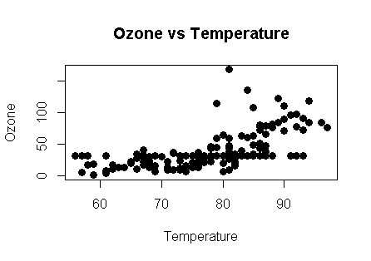

3. Visualization 2: Average Ozone by Temperature Group
Purpose:
A bar chart was used to compare the average ozone concentration across different temperature groups. Bar charts are useful for comparing values between categories clearly.
R Code
Air_Quality_Cleaned$Temp_Group <- cut(
Air_Quality_Cleaned$Temp,
breaks = c(-Inf, 70, 80, Inf),
labels = c("Low (≤70)", "Moderate (71-80)", "High (>80)")
)

ozone_by_group <- tapply(
Air_Quality_Cleaned$Ozone,
Air_Quality_Cleaned$Temp_Group,
mean
)

barplot(
ozone_by_group,
main = "Average Ozone by Temperature Group",
xlab = "Temperature Group",
ylab = "Average Ozone",
col = c("skyblue", "gold", "tomato")
)
Interpretation:
The bar chart compares the average ozone concentration for low, moderate, and high temperature groups. The chart shows that ozone concentration varies across temperature groups. The higher temperature groups generally show higher average ozone values, supporting the positive relationship observed in the scatter plot.

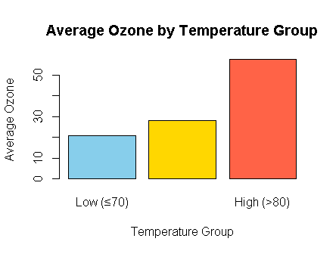

4. Visualization 3: Temperature Trend Over Time
Purpose:
A line chart was selected to show how temperature changes over time. Line charts are useful for identifying trends and fluctuations across a sequence of observations.
R Code
Air_Quality_Cleaned$Date <- as.Date(Air_Quality_Cleaned$Date)

plot(
Air_Quality_Cleaned$Date,
Air_Quality_Cleaned$Temp,
type = "o",
main = "Temperature Trend Over Time",
xlab = "Date",
ylab = "Temperature",
pch = 19
)
Interpretation:
The line chart shows the variation in temperature across the observation period. Temperature does not remain constant and shows several increases and decreases over time. This visualization helps identify changes and fluctuations in temperature throughout the dataset.
5. Visualization 4: Distribution of Ozone Concentratio

Purpose:
A histogram was selected to understand the distribution and frequency of ozone concentration values. It helps identify the range where most observations are concentrated and whether the data has any unusual spread. R Code

R Code
hist(
Air_Quality_Cleaned$Ozone,
breaks = 12,
main = "Distribution of Ozone Concentration",
xlab = "Ozone",
ylab = "Frequency",
col = "lightblue",
border = "white"
)
Interpretation:
The histogram shows how ozone concentration values are distributed across different ranges. Most observations are concentrated in the lower to middle ozone ranges, while a few observations have considerably higher values. This indicates that the dataset contains some relatively high ozone observations.

6. Overall Findings
• The scatter plot showed a moderate positive relationship between temperature and ozone concentration.

• The bar chart showed differences in average ozone concentration across the temperature groups.

• The line chart showed that temperature varied over the observation period, with several increases and decreases.

• The histogram showed that most ozone observations were concentrated in the lower to middle range, with some higher values.

• Different visualization types helped present the dataset from different perspectives and made the patterns easier to understand.
This project demonstrated how R can be used to create meaningful and informative visualizations from a cleaned dataset. Four different visualizations were created: scatter plot, bar chart, line chart, and histogram. Each visualization provided a different view of the air quality data. The analysis showed a positive association between temperature and ozone concentration and highlighted variations in temperature and ozone distribution. These visualizations make the results easier to understand for both technical and non-technical audiences.
8. Tools Used
• R
• RStudio
• Microsoft Word
• Base R plotting functions

